1. What are three conclusions we can make about Kickstarter campaigns given the provided data?

Conclusion 1:

Overall, the most common category of campaign is Theater; as a result it has the most successes and the most failures. The drill down is as follows.

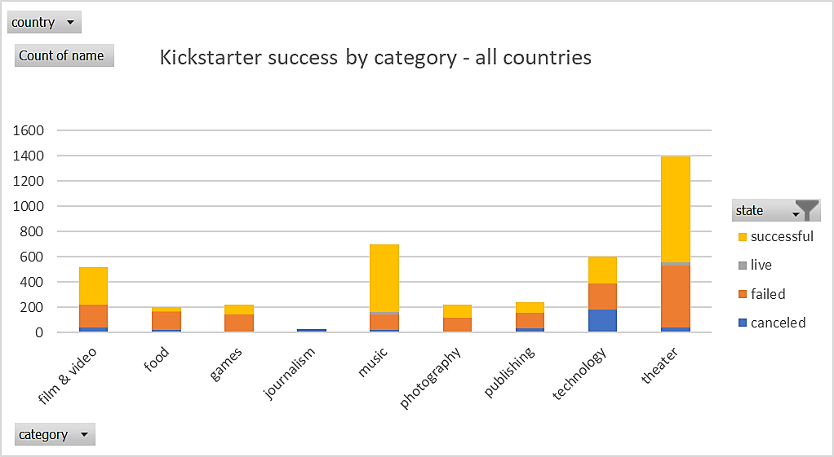

The top 3 categories for successful Kickstarter campaigns have been:

* Theater
* Music
* Film & video

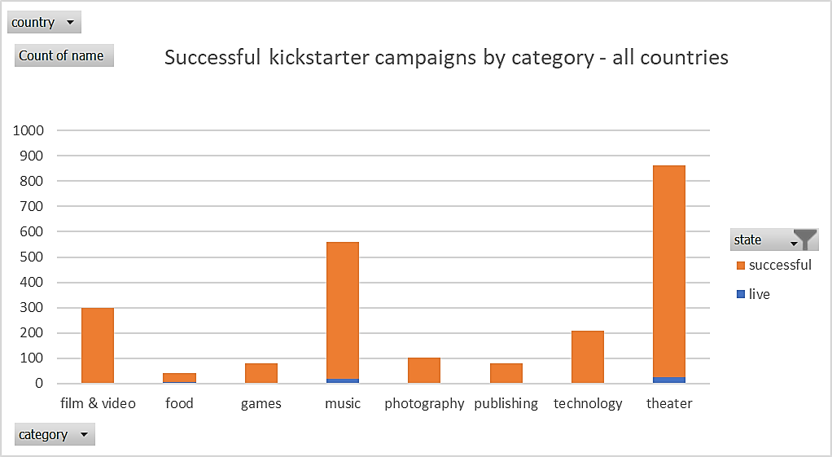

The 3 least successful Kickstarter campaign categories have been:

* Theater
* Technology
* Film & video

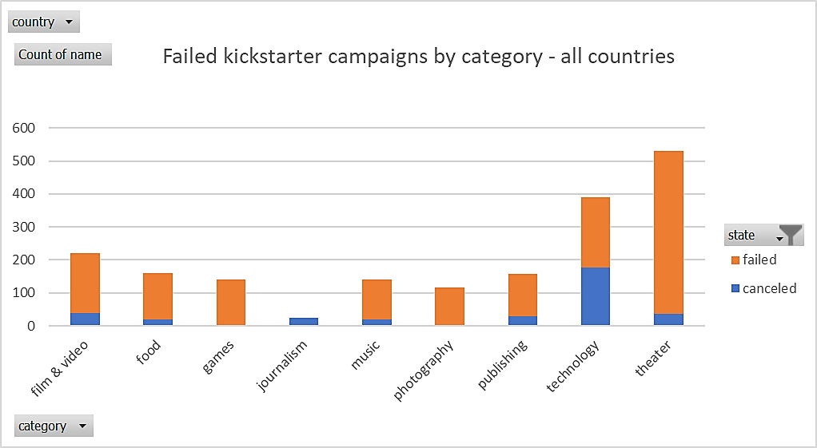

Conclusion #2:

The most common sub category is **Plays** (nested under the Theater category).

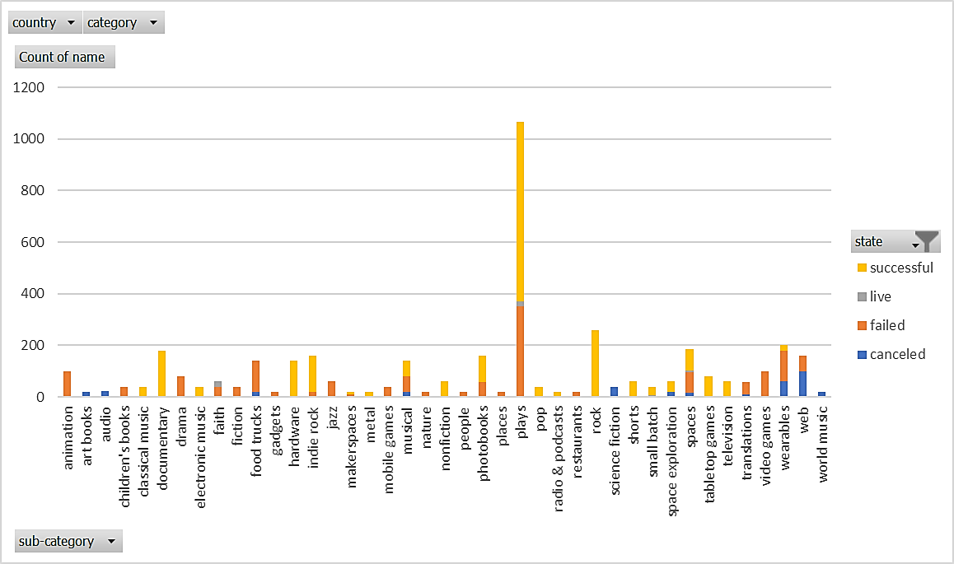

Conclusion #3:

December is the **least** successful month of the year to set a deadline for a Kickstarter campaign.

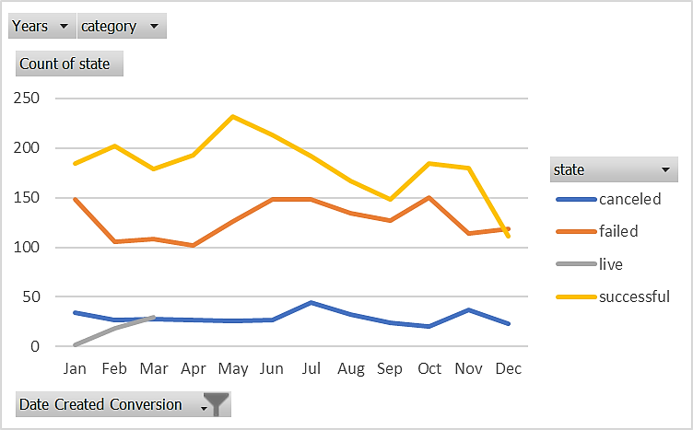

1. What are some of the limitations of this dataset?
   * Unclear **why** the donors pledged money to certain causes.
   * Who are the donors? Unclear if the donors are unique for every campaign (maybe 1 person is donating the majority of the funds for all the different plays in the US?)
   * How realistic were the budgets? It’s easier to fund a lower budget but maybe it’s not enough to execute the campaign.
   * How long does it take for campaigns to reach their goal? We should have a column showing when the campaign reached their goal since some are over 100% funded.
2. What are some other possible tables/graphs that we could create?
   * Average $ amount/category – some of these categories require less funding than others. (Technology received the most funding overall, fig. A)
   * % of funding – which categories got the closest even though they had failures? (Technology, fig. B)
   * Filter by year…which campaigns are trending up and less likely to have over saturation? (Theater is trending down, fig. C)

Fig. A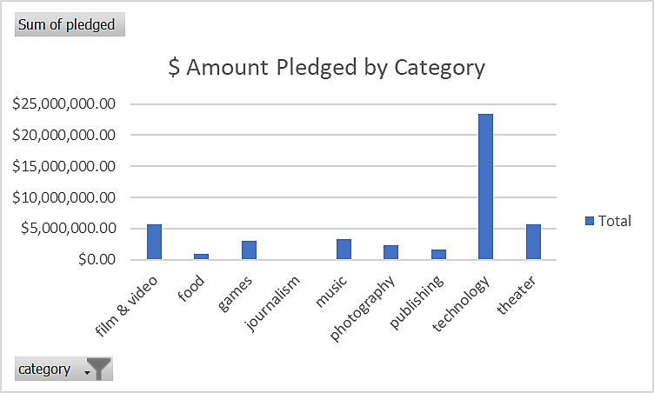

Fig. B 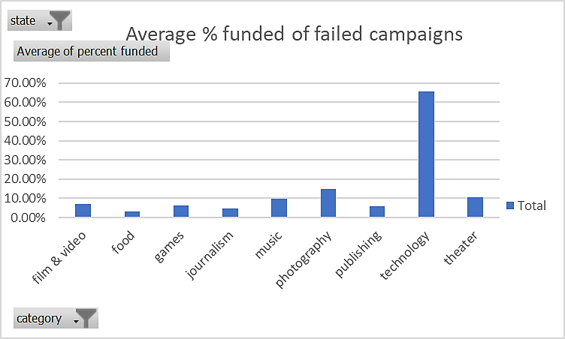

Fig. C 